**Mathematics Learning Experience for Grade 2 (C12)**

Activity 1: Study the price list of fruits per kilogram then answer the questions that follow.

**Let’s be healthy!**

**Fruit Stand**

Price per Kilogram

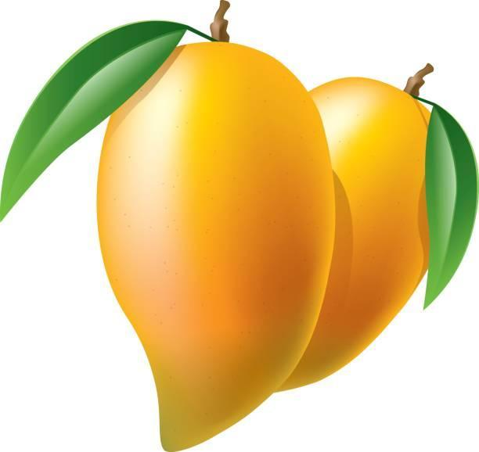



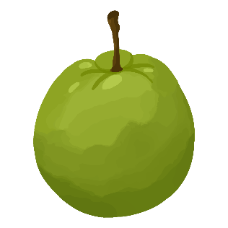

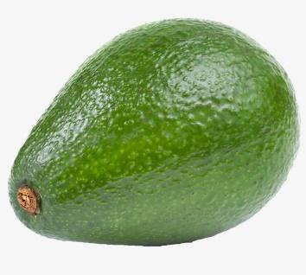



1. Which fruit is the cheapest?
2. Which fruit is the most expensive?
3. How much more expensive are bananas than mangoes?
4. Which is cheaper, avocado or pineapple? How much cheaper?
5. Which more expensive, mangoes or guavas? How much more expensive?

Activity 2

**Math Word Problems**



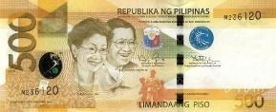

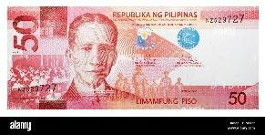



Activity 3:

**Shopping Time!**

One Saturday morning, Mother and Barbie went to the mall and buy some school supplies for the opening of classes. They buy bag worth- ₱392, pad paper-₱70, notebooks- ₱150, pencils-P50 and some coloring materials worth ₱220. If Mother gave ₱1 000, how much is her change?

| Items bought | Thousands | Hundreds | Tens | Ones |
| --- | --- | --- | --- | --- |
| bag |  | 3 | 9 | 2 |
| Pad paper |  |  | 7 | 0 |
| notebooks |  | 1 | 5 | 0 |
| pencils |  |  | 5 | 0 |
| Coloring materials |  | 2 | 2 | 0 |
| **Total** |  | **8** | **8** | **2** |

Materials (Ready to Print)

**0 1** 

**2 3**

**4 5**

**6 7**

**8 9**

